Bzone_Unprotected_Area.csv
May 20, 2026

Definition

This CSV file has three attributes (UrbanArea, TownArea, and RuralArea) which yield the total area of unprotected (developable) land in each block group, or Bzone, in Virginia, categorized as Urban, Town, or Rural. The units are in acres. These values are shown below for three bzones: 515400010001 (an urban area near Charlottesville’s downtown pedestrian mall), 510030107021 (a suburban area near Route 29 in Albemarle County), and 510030110004 (a rural residential area in Albemarle County). All acres not protected from development fall into the urban category for the first two zones. For the rural area, half the unprotected acres are categorized as town and the other half are categorized as rural.

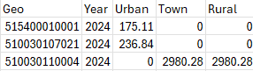

For year 2045, values are presumed to be the same as for year 2024.

Possible Scenario

Changing the number of unprotected acres by itself does not have any corresponding scenario. However, as noted in the document Task 7.2 Simplified Scenario Development guide, available at A Playbook for Simplified Approaches for Creating Scenarios in VisionEval, changes to two related files—bzone_network_design.csv and bzone_urban-mixed-use_prop.csv can help one do the following: if we make an area more walkable, how does that influence VMT by reducing driving trips and replacing them with walking trips? This file appears to be necessary for such a question because only urban and town areas, but not rural areas, can be defined as walkable. Thus, this file is an input required to execute the scenarios described in association with bzone_network_design.csv and bzone_urban-mixed-use prop.csv.

Method Used for Virginia

Three different steps are needed:

            - Determine the total amount of unprotected area for each Bzone
            - Determine whether each Bzone is urban, town, rural or some combination thereof
            - Combine the results from steps (1) and (2)

Steps 1 and 3 are straightforward, and step 2 requires judgment.

- Determining the Total Amount of Unprotected Area

The Smart Location Database has a field called Ac_Unpr which is the “Total land area (acres) that is not protected from development (i.e., not a park, natural area or conservation area).” GIS processing (in this case, the Summarize Within Tool) was used to get a total amount of unprotected land for each Bzone. (Rather than a spatial join, the summarize within tool was used. The reason for this was to get the best estimate of the number of acres when accounting for the fact that block group boundaries between the EPA Smart Location Database and those used in Virginia may not align perfectly.) For example, that processing showed that bzone 510010901011 has 984.18 unprotected acres.

All of Virginia’s 5,963 Bzones had a total unprotected acres greater than zero with nine exceptions. These 9 Bzones appear to all be water-only. An example of such a Bzone is shown in Figure 1, which contains Bzone 510019902000.

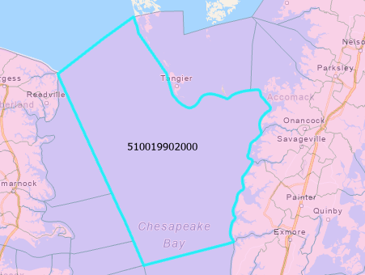
Figure 1. A Water-Only Bzone where there are no acres unprotected from development.

- Categorizing Bzones as Urban, Town, and Rural

In terms of how to classify areas within the Bzone as urban, rural, or town, the document Task 7.2 Simplified Scenario Development guide (A Playbook for Simplified Approaches for Creating Scenarios in VisionEval) states that “The classification of the urban, town, and rural is generally up to the user.” Indeed this appears to be the case, given two contradictory examples:

        - A bzone should be either only urban, only town, or only rural. The VisionEval documentation (e.g., https://visioneval.github.io/docs/model-inputs.html) indicates that in the past, areas of 50,000 or more people were considered urban, areas of 2,500 - 50,000 people are town, and everything else is rural. Elsewhere in the same document, the guidance states that “One method is to define land in MPO boundaries to be metro, for urban areas smaller than MPOs, land inside their UGB is a town. Everything else is rural.” (emphasis in the original). To the extent that bzones align with census geographies, one would expect a bzone to thus be completely urban, completely town, or completely rural.

        - A bzone could be a mix of urban, town, or rural. A review of the input file associated with the Rogue Valley MPO (RVMPO, the default files given with VisionEval) showed a different approach. For the 210 bzones and based on the amount of unprotected area (e.g., available for development), 104 bzones were completely urban, 17 were completely rural, and 87 had some urban and some rural.

Overall, it is critical that this classification of rural, town, and urban (or metro) be consistent with another input 31_bzone_urban_town_dwelling_prop which also gives the proportion of dwelling units in urban and town areas (and by subtraction, the proportion in rural areas is implied).

Accordingly, an approach was chosen that sought to initially categorize areas as urban, town, or rural. A dataset was obtained from ESRI titled “Urban and Rural Population in the U.S. (2020 Census) - Overview” which had the percent of population that is urban in each block group. A spatial join was performed, and then based on examining areas in Charlottesville/Albemarle and Culpeper, bzones were categorized as follows:

- Urban if the Bzone has at least 75% of its population as urban
- Town if the Bzone has more than 0% of its population
- Rural if 0% of the population is urban

3. Combine the results from steps (1) and (2)

The Playbook for Simplified Approaches for Creating Scenarios in VisionEval offers, however, two additional factors that were not immediately apparent to the research team and which make one consider not making unprotected acres entirely rural.

One concerns the use of mixed-use neighborhoods, where the guidance notes that when VisionEval performs land use modeling, two key input files—intersection density and proportion of development in a mixed use area—only applies to urban or town areas. That would mean that if one designated a bzone as rural only, one would not be able to examine a policy related to having some of the bzone be mixed use in the future. Thus rather than designating unprotected areas for a bzone as rural only, one might want to have such unprotected acres be rural only at present and then in the future have those unprotected acres be partly rural and partly town. A simpler approach, however, might be to simply have the unprotected acres be partly rural and partly town, and then shift the proportion of development (using bzone_urban_town_dwelling_prop) between these.

The other concerns trip diversion, where the Playbook mentions that azone_prop_sov_dvmt_diverted.csv is applicable only to urban or town areas.

Accordingly, to provide flexibility, the approach that was used was for rural zones to designate half their unprotected areas as rural and other half of their unprotected areas as town. It may be appropriate to change these percentages in the future, but for now it appears one can thus use the attribute bzone_urban_town_dwelling_prop to then shift growth between rural areas and towns.

Sources

ESRI. Urban and Rural Population in the U.S. (2020 Census) – Overview. https://www.maps.arcgis.com/home/item.html?id=0f98fc66a9fa4f94953718578cbd77a8. Accessed March 10, 2026.

Scrap for Internal Use

      - The link https://visioneval.github.io/docs/model-inputs.html#verspm-inputs has a definition for each CSV file

      - The document Task 7.2 Simplified Scenario Development guide is available at this link: A Playbook for Simplified Approaches for Creating Scenarios in VisionEval but does not mention bzone_unprotected_area

      - This used the Smart Location Database at D:\VE2025\BlockGroupsBZones\Align. The left item was done first (to get total acres) and the right item was done second (get initial rural, urban, town categories).

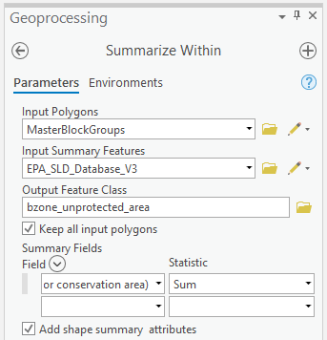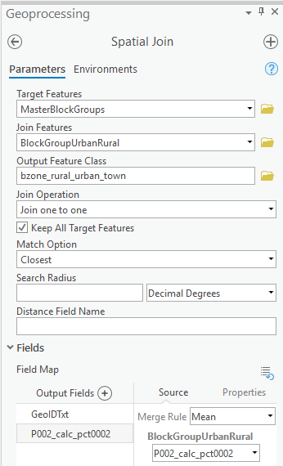

- Then Excel processing was done in the bzone_unprotected_area.xlsx to get the bzone data for each bzone shown in columns E, M, N, and O.

Examples of old pictures are below.
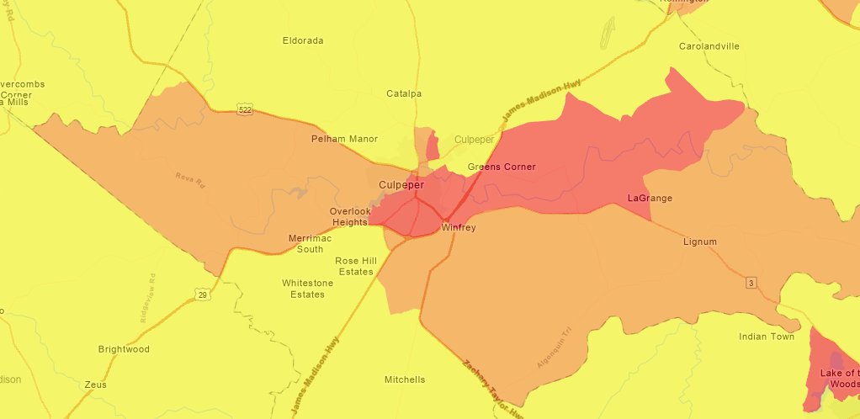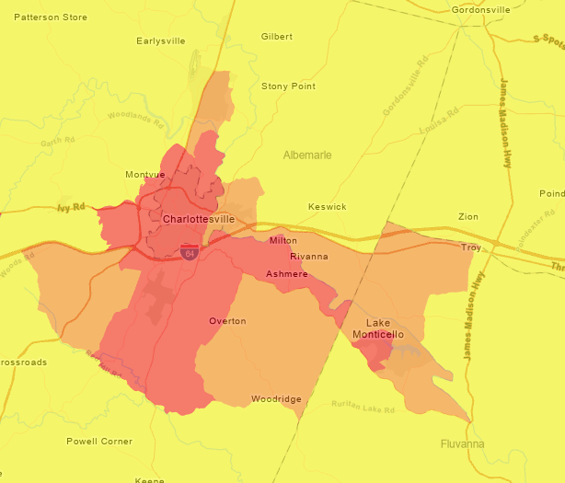

Metadata from ESRI source.

Urban and Rural Population in the U.S. (2020 Census)
Tags Demographics, Census, Census Bureau, United States, U.S., Total Population, P1, H1, H3, P2, P3, P5, P12, P13, P17, PCT12, Nation, State, County, Census Tract, Block Group, predominance, USA
Summary
This map's colors indicate which population is larger in each area: urban or rural. Data is from the U.S. Census Bureau’s 2020 Census Demographic and Housing Characteristics. The map's layers contain total population counts by sex, age, and race groups for Nation, State, County, Census Tract, and Block Group in the United States and Puerto Rico.
Description
This map's colors indicate which population is larger in each area: urban (green) or rural (yellow). The map's layers contain total population counts by sex, age, and race groups for Nation, State, County, Census Tract, and Block Group in the United States and Puerto Rico.
The U.S. Census designates each census block as part of an urban area or as rural. Larger geographies in this map such as block group, tract, county and state can therefore have a mix of urban and rural population. This map illustrates the 100% urban areas in dark green, and 100% rural areas in dark yellow. Areas with mixed urban/rural population have softer shades of green or yellow, to give a visual indication of where change may be happening. From the Census:

- "The Census Bureau’s urban-rural classification is a delineation of geographic areas, identifying both individual urban areas and the rural area of the nation. The Census Bureau’s urban areas represent densely developed territory, and encompass residential, commercial, and other non-residential urban land uses. The Census Bureau delineates urban areas after each decennial census by applying specified criteria to decennial census and other data. Rural encompasses all population, housing, and territory not included within an urban area.

- For the 2020 Census, an urban area will comprise a densely settled core of census blocks that meet minimum housing unit density and/or population density requirements. This includes adjacent territory containing non-residential urban land uses. To qualify as an urban area, the territory identified according to criteria must encompass at least 2,000 housing units or have a population of at least 5,000." Source

About the data

You can use this map as is and you can also modify it to use other attributes included in its layers.

This map's layers contain total population counts by sex, age, and race groups data from the 2020 Census Demographic and Housing Characteristics. This is shown by Nation, State, County, Census Tract, Block Group boundaries. Each geography layer contains a common set of Census counts based on available attributes from the U.S. Census Bureau. There are also additional calculated attributes related to this topic, which can be mapped or used within analysis.

Vintage of boundaries and attributes: 2020
Demographic and Housing Characteristics Table(s): P1, H1, H3, P2, P3, P5, P12, P13, P17, PCT12 (Not all lines of these DHC tables are available in this feature layer.)
Data downloaded from: U.S. Census Bureau’s data.census.gov site
Date the Data was Downloaded: May 25, 2023
Geography Levels included: Nation, State, County, Census Tract, Block Group
National Figures: included in Nation layer

The United States Census Bureau Demographic and Housing Characteristics:
- 2020 Census Results
- 2020 Census Data Quality
- Geography & 2020 Census
- Technical Documentation
- Data Table Guide: includes the final list of tables, lowest level of geography by table and table shells for the Demographic Profile and Demographic and Housing Characteristics.
- News & Updates
This map is ready to be used in ArcGIS Pro, ArcGIS Online and its configurable apps, Story Maps, dashboards, Notebooks, Python, custom apps, and mobile apps. Data can also be exported for offline workflows. Please cite the U.S. Census Bureau when using this data.

Data Processing Notes:
- These 2020 Census boundaries come from the US Census TIGER geodatabases. These are Census boundaries with water and/or coastlines erased for cartographic and mapping purposes. For Census tracts and block groups, the water cutouts are derived from a subset of the 2020 Areal Hydrography boundaries offered by TIGER. Water bodies and rivers which are 50 million square meters or larger (mid to large sized water bodies) are erased from the tract and block group boundaries, as well as additional important features. For state and county boundaries, the water and coastlines are derived from the coastlines of the 2020 500k TIGER Cartographic Boundary Shapefiles. These are erased to more accurately portray the coastlines and Great Lakes. The original AWATER and ALAND fields are unchanged and available as attributes within the data table (units are square meters).
- The layer contains all U.S. states, Washington D.C., and Puerto Rico.
- Census tracts with no population that occur in areas of water, such as oceans, are removed from this data service (Census Tracts beginning with 99). Block groups that fall within the same criteria (Block Group denoted as 0 with no area land) have also been removed.
- Percentages and derived counts, are calculated values (that can be identified by the "_calc_" stub in the field name).
- Field alias names were created based on the Table Shells file available from the Data Table Guide for the Demographic Profile and Demographic and Housing Characteristics.
- Not all lines of all tables listed above are included in this layer. Duplicative counts were dropped. For example, P0030001 was dropped, as it is duplicative of P0010001.
To protect the privacy and confidentiality of respondents, their data has been protected using differential privacy techniques by the U.S. Census Bureau.
Credits
U.S. Census Bureau, Esri
Use limitations
This work is licensed under the Esri Master License Agreement.
View Summary | View Terms of Use
Extent
There is no extent for this item.
Scale Range
There is no scale range for this item.

You are currently using the Item Description metadata style. Change your metadata style in the Options dialog box to see additional metadata content.

